**Assignment 2**

**Web Technology**

**Topic:**

Admission Form using HTML CSS

**Submitted to:**

Madam Syeda Fatima

**Submitted By:**

Syed Usman Hassan

FA19-BCS-106

(B)

**COMSATS University Islamabad**

Sahiwal Campus

Output:

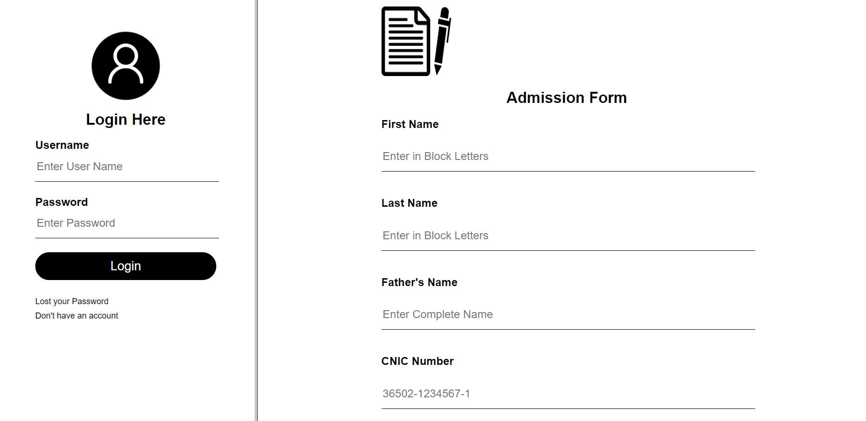

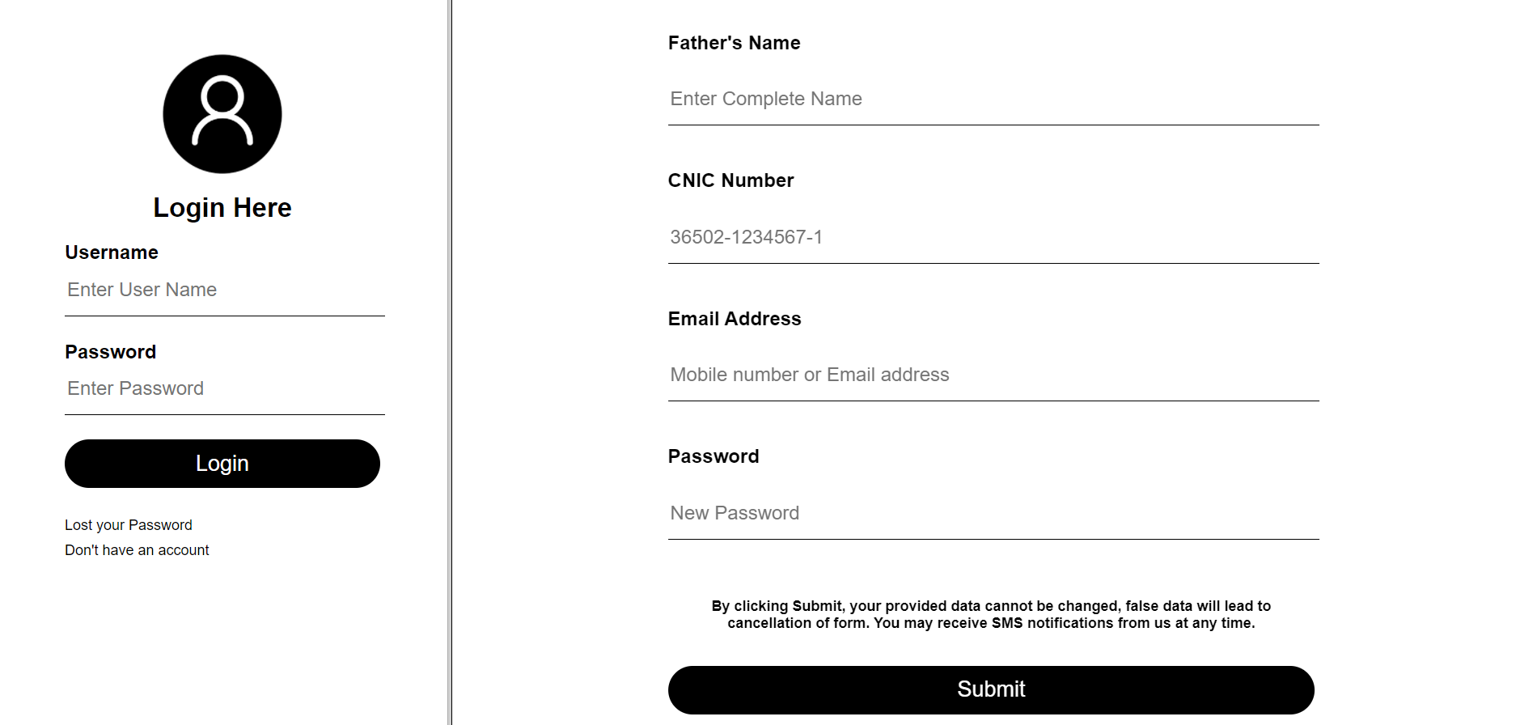

INDEX Code:

HTML:

<!DOCTYPE html>

<html lang="en">

<head>

    <meta charset="UTF-8">

    <meta http-equiv="X-UA-Compatible" content="IE=edge">

    <meta name="viewport" content="width=device-width, initial-scale=1.0">

    <title>Document</title>

    <link rel="stylesheet" href="style.css">

    <frameset cols="35,85">

        <frame src="../frame2/frame2.html">

        <frame src="../frame3/frame3.html">

    </frameset>

</head>

<body>

</body>

</html>

External CSS:

NOT Applied

Frame 1 Code:

HTML:

<!DOCTYPE html>

<html lang="en">

<head>

    <meta charset="UTF-8">

    <meta http-equiv="X-UA-Compatible" content="IE=edge">

    <meta name="viewport" content="width=device-width, initial-scale=1.0">

    <title>Document</title>

    <link rel="stylesheet" href="style.css">

</head>

<body>

    <div class="loginbox">

            <img src="v1.png" class="vector">

            <h1>Login Here</h1>

            <form>

                <p>Username</p>

                <input type="text" placeholder="Enter User Name">

                <p>Password</p>

                <input type="password" placeholder="Enter Password">

                <input type="submit" value="Login">

                <a href="#">Lost your Password</a><br>

                <a href="#">Don't have an account</a>

            </form>

    </div>

</body>

</html>

External CSS:

body{

    margin:0;

    padding: 0;

    font-family: sans-serif;

}

.bgimage{

    width: 100vw;

    height: 100vh;

    position: relative;

    background-repeat: no-repeat;

    background: linear-gradient(rgba(0,0,0,0.7),rgba(0,0,0,0.8)),url(bg1.png);

    background-size: cover ;

    background-position: center;

}

.loginbox{

    width: 320px;

    height: 420px;

    background: #fff;

    color: black;

    top: 50%;

    left: 50%;

    position: absolute;

    transform: translate(-50%,-50%);

    box-sizing: border-box;

    padding: 50px 30px;

}

.vector{

    height: 100px;

    width: 100px;

    border-radius:50%;

    position: absolute;

    top: -50px;

    left: calc(50% - 50px);

}

h1{

    margin: 45;

    padding: 0,0,20px;

    text-align: center;

    font-size: 22px;

    color: black;

}

.loginbox p{

    margin: 0;

    padding: 0;

    font-weight: bold;

}

.loginbox input{

    width: 100%;

    margin-bottom: 20px;

}

.loginbox input[type="text"],input[type="password"]

{

    border: none;

    border-bottom: 1px solid #000;

    background: transparent;

    outline: none;

    height: 40px;

    font-size: 16px;

}

.loginbox input[type="submit"]

{

    border: none;

    outline: none;

    height: 40px;

    background: black;

    color: #fff;

    font-size: 18px;

    border-radius: 20px;

}

.loginbox input[type="submit"]:hover

{

    cursor: pointer;

    background: grey;

    color: black;

}

.loginbox a{

    text-decoration: none;

    font-size: 12px;

    line-height: 20px;

    color: black;

}

.loginbox a:hover{

    cursor: pointer;

    color: blue;

}

Frame 2 Code:

HTML:

<!DOCTYPE html>

<html lang="en">

<head>

    <meta charset="UTF-8">

    <meta http-equiv="X-UA-Compatible" content="IE=edge">

    <meta name="viewport" content="width=device-width, initial-scale=1.0">

    <title>Document</title>

    <link rel="stylesheet" href="style.css">

</head>

<body>

    <div class="signbox">

        <img src="img.jpg" class="vector">

        <h1>Admission Form</h1>

        <form>

            <p>First Name</p>

            <input type="text" placeholder="Enter in Block Letters" required>

            <p>Last Name</p>

            <input type="text" placeholder="Enter in Block Letters" required>

            <p>Father's Name</p>

            <input type="text" placeholder="Enter Complete Name" required>

            <p>CNIC Number</p>

            <input type="text" pattern="[0-9]{5}[-][0-9]{7}[-]{0-9}{1}" placeholder="36502-1234567-1" required>

            <p>Email Address</p>

            <input type="text" placeholder="Mobile number or Email address" required>

            <p>Password</p>

            <input type="password"placeholder="New Password" required>

            <h6 color="blue">By clicking Submit, your provided data cannot be changed, false data will lead to cancellation of form.

            You may receive SMS notifications from us at any time.</h6>

            <input type="submit" value="Submit">

        </form>

    </div>

</body>

</html>

External CSS:

body{

    margin:0;

    padding: 0;

    font-family: sans-serif;

}

.vector{

    height: 100px;

    width: 100px;

    top: -500px;

    left: calc(50% - 50px);

}

.signbox{

    width: 60%;

    height:100%;

    background: white;

    color: black;

    top: 55%;

    left: 50%;

    position: absolute;

    transform: translate(-50%,-50%);

    box-sizing: border-box;

    padding: 50px 30px;

}

.signbox{

    margin: 0;

    padding: 0;

    font-weight: bold;

}

h1{

    margin: 45;

    padding: 0,0,20px;

    text-align: center;

    font-size: 22px;

    color: black;

}

h6{

    margin: 45;

    padding: 0,0,20px;

    text-align: center;

    font-size: 12px;

    color: black;

}

.signbox input{

    width: 100%;

    margin-bottom: 20px;

}

.signbox input[type="text"],input[type="password"]

{

    border: none;

    border-bottom: 1px solid #000;

    background: transparent;

    outline: none;

    height: 40px;

    font-size: 16px;

}

.signbox input[type="submit"]

{

    border: none;

    outline: none;

    height: 40px;

    background: black;

    color: #fff;

    font-size: 18px;

    border-radius: 20px;

}

.signbox input[type="submit"]:hover

{

    cursor: pointer;

    background: grey;

    color: black;

}